**WEEK 6**

**1.ReactJS-HOL**

**STEP 1:** To create a new React app, Install Nodejs and Npm from the following link:

<https://nodejs.org/en/download/>

**STEP 2:** Install Create-react-app by running the following command in the command prompt:



**STEP 3:** To create a React Application with the name of “myfirstreact”, type the following command:



**STEP 4:** Once the App is created, navigate into the folder of myfirstreact by typing the following command:



**App.js:**

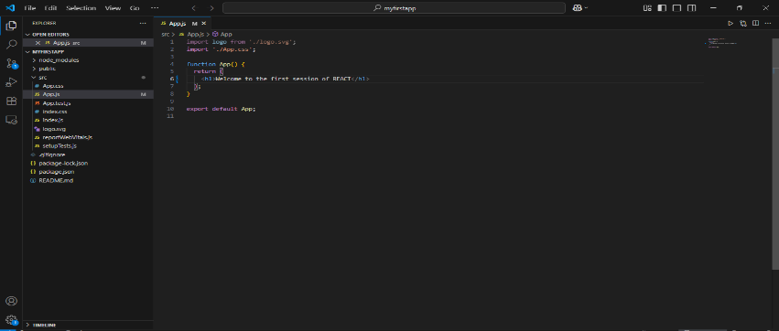

**STEP 5:** To run



**OUTPUT:**

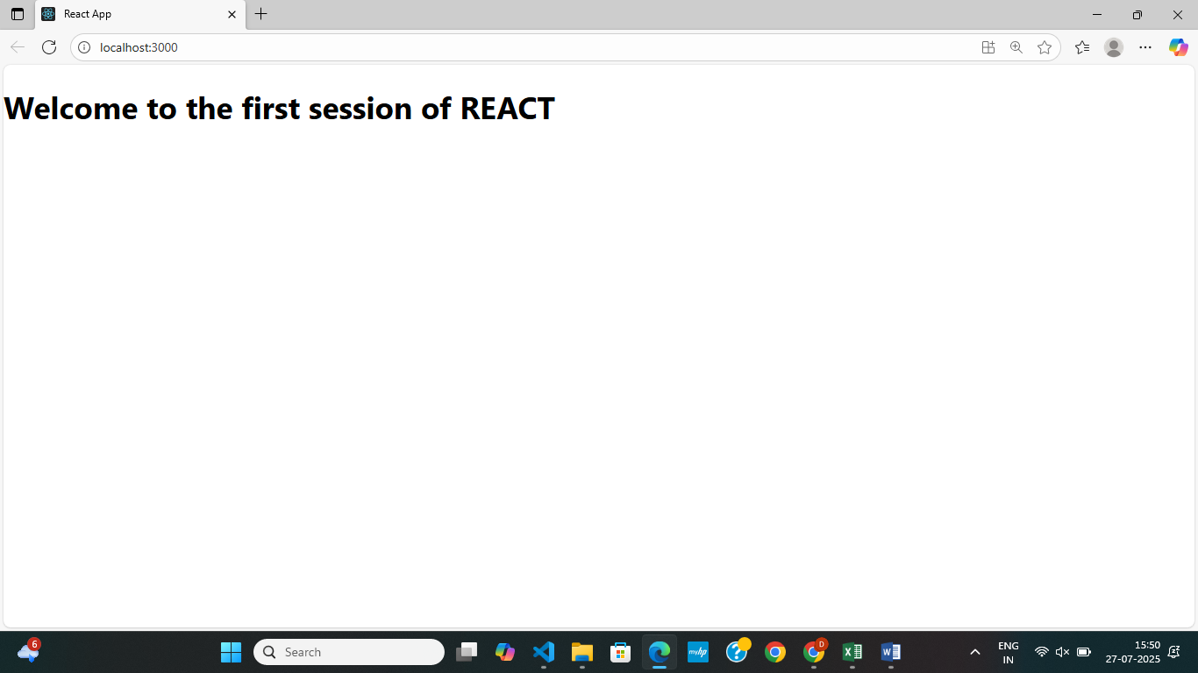

**2. ReactJS-HOL**

**STEP 1:** To create a new React app, Install Nodejs and Npm from the following link:

<https://nodejs.org/en/download/>

**STEP 2:** Install Create-react-app by running the following command in the command prompt:



**STEP 3:** To create a React Application with the name of “studentapp”, type the following command:



**STEP 4:** Once the App is created, navigate into the folder of studentapp by typing the following command:

C:>cd studentapp

lHome.js

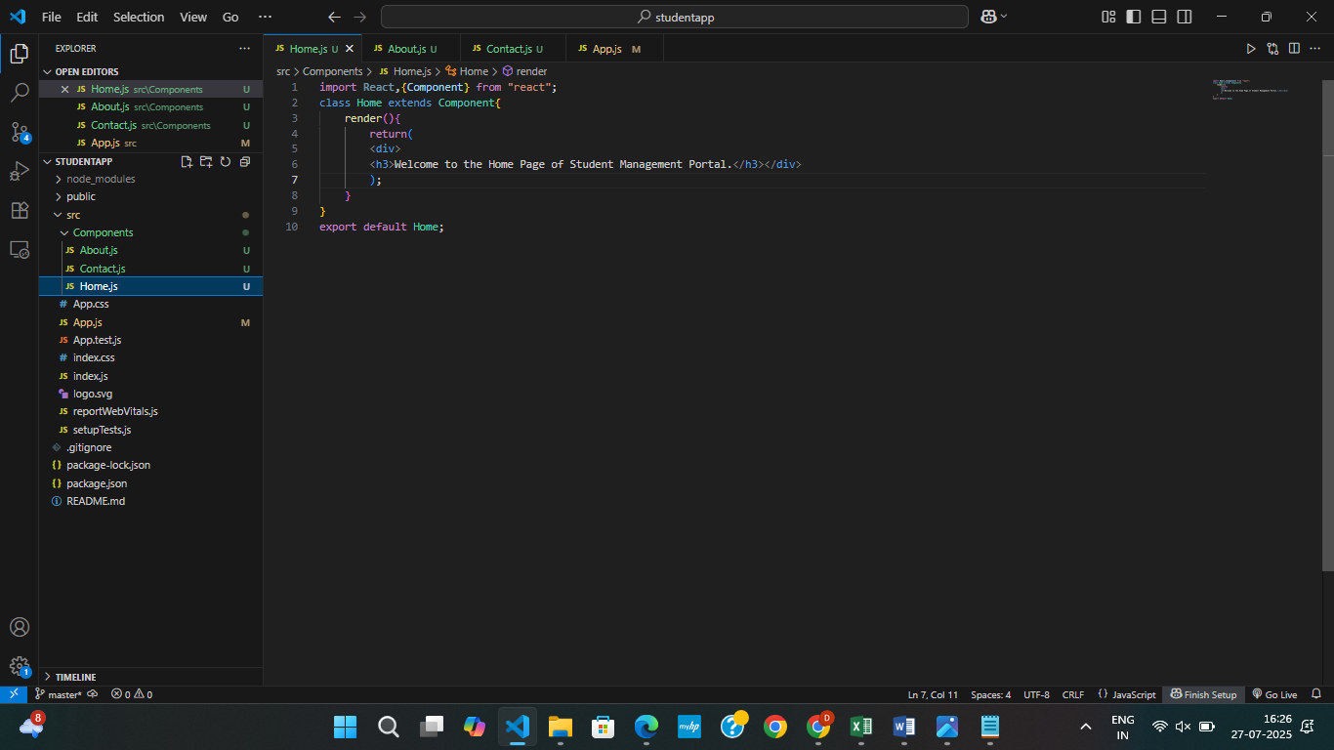

About.js

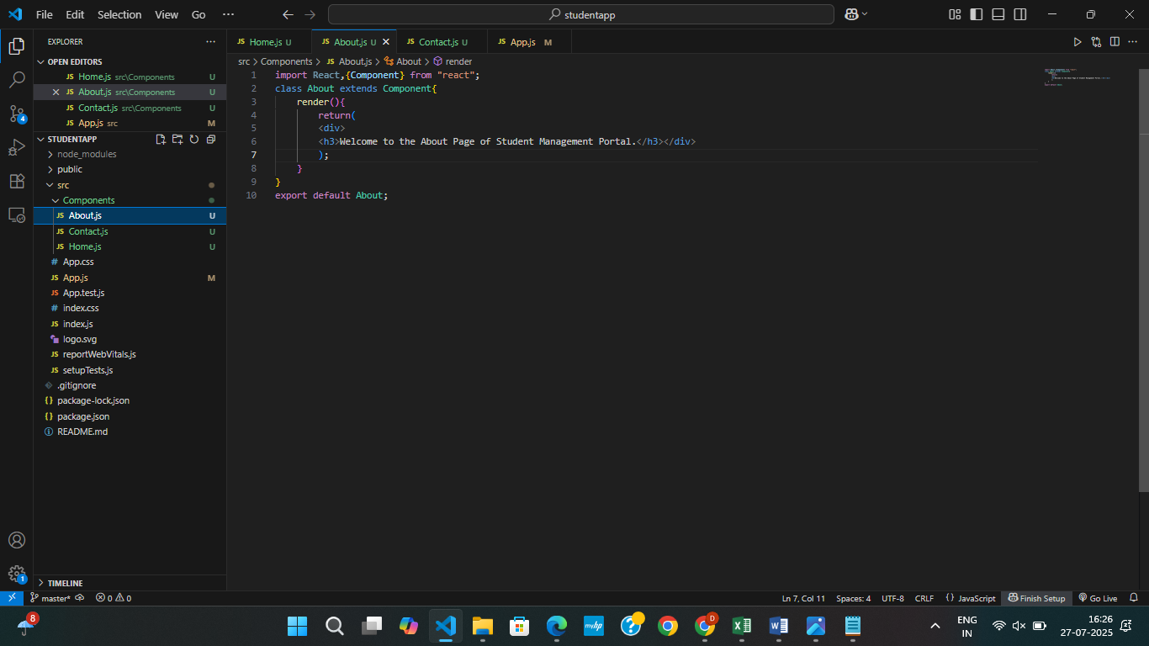

**Contact.js**

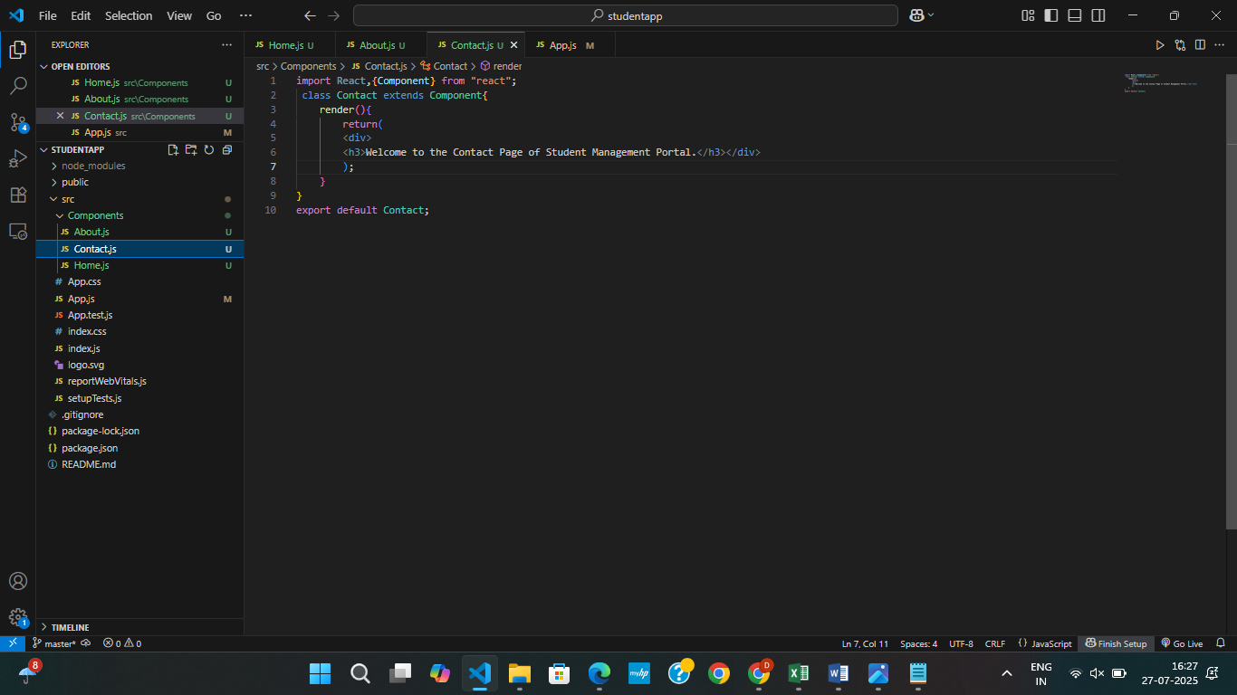

**App.js:**

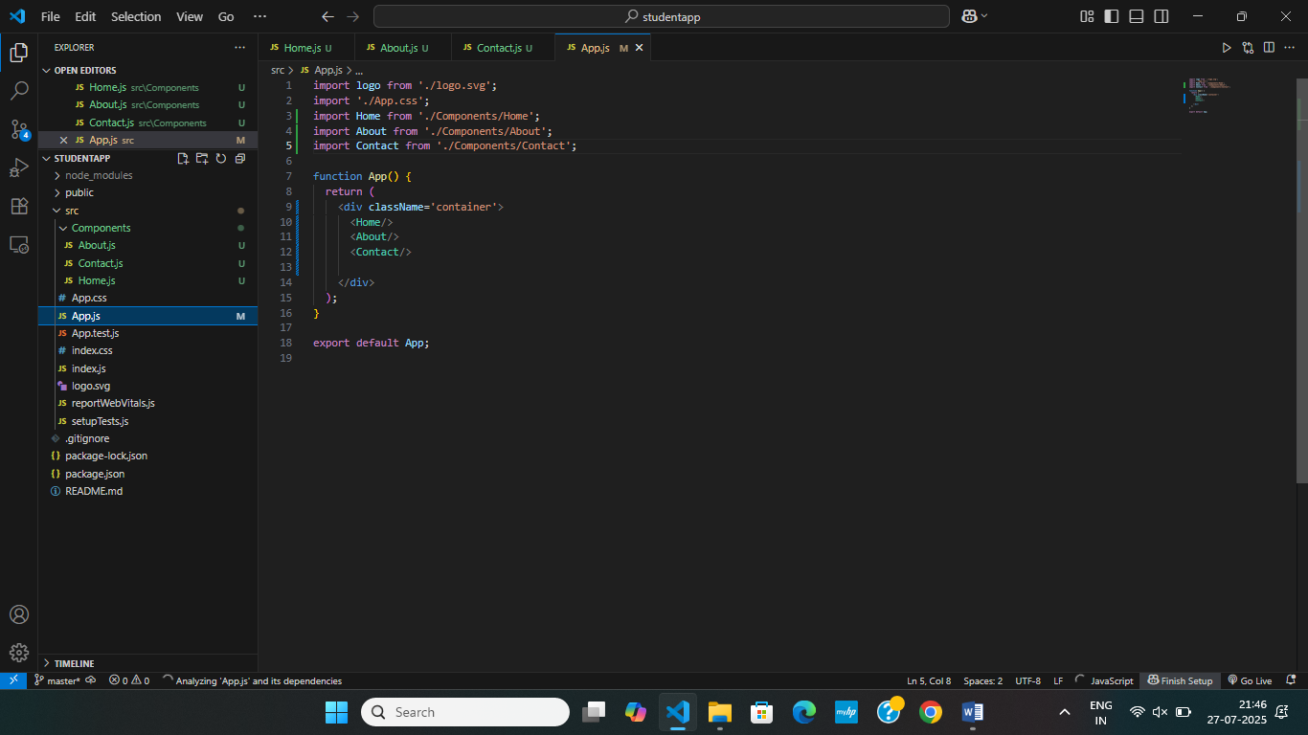

**STEP 5:** To run



**OUTPUT:**

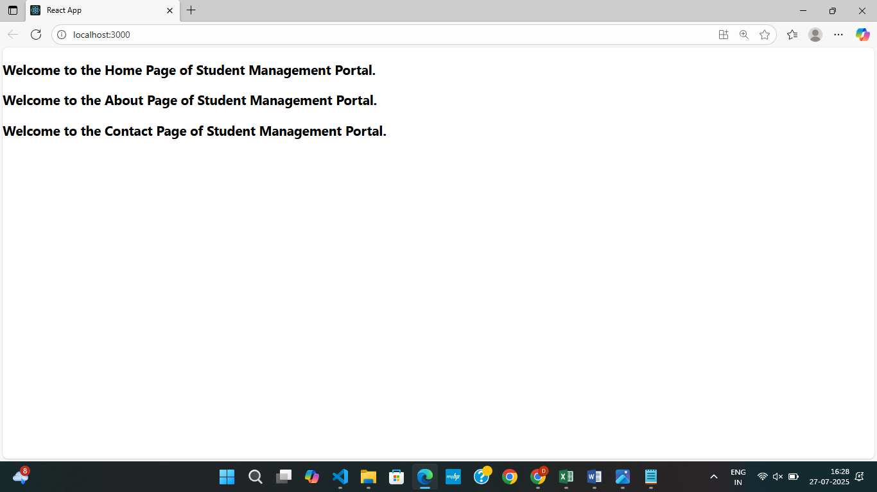

**3. ReactJS-HOL**

**STEP 1:** To create a new React app, Install Nodejs and Npm from the following link:

<https://nodejs.org/en/download/>

**STEP 2:** Install Create-react-app by running the following command in the command prompt:



**STEP 3:** To create a React Application with the name of “studentapp”, type the following command:



**STEP 4:** Once the App is created, navigate into the folder of studentapp by typing the following command:

C:>cd scorecalculatorapp

Calculatorscore.js

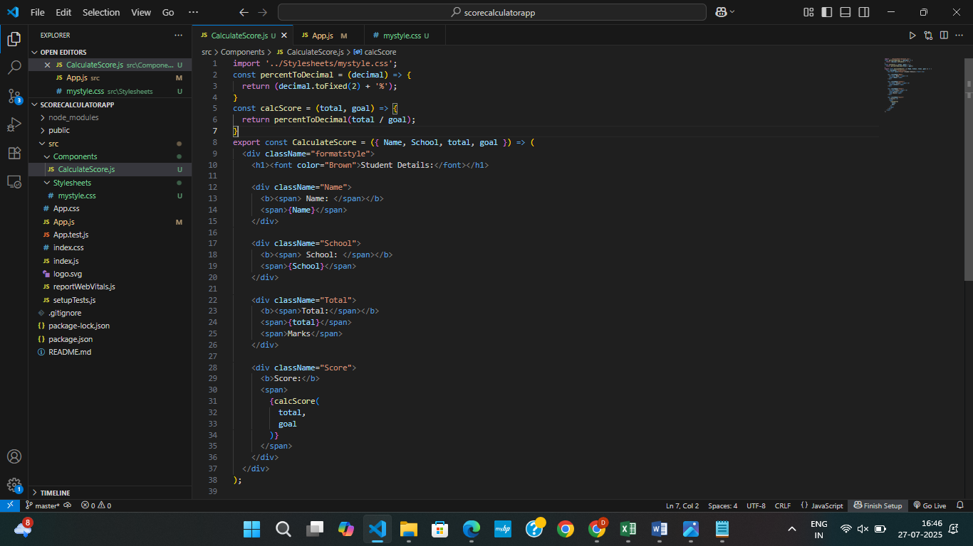

mystyle.css

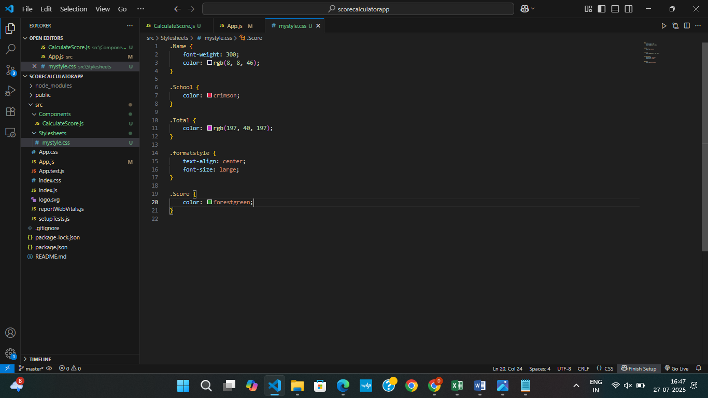

App.js:

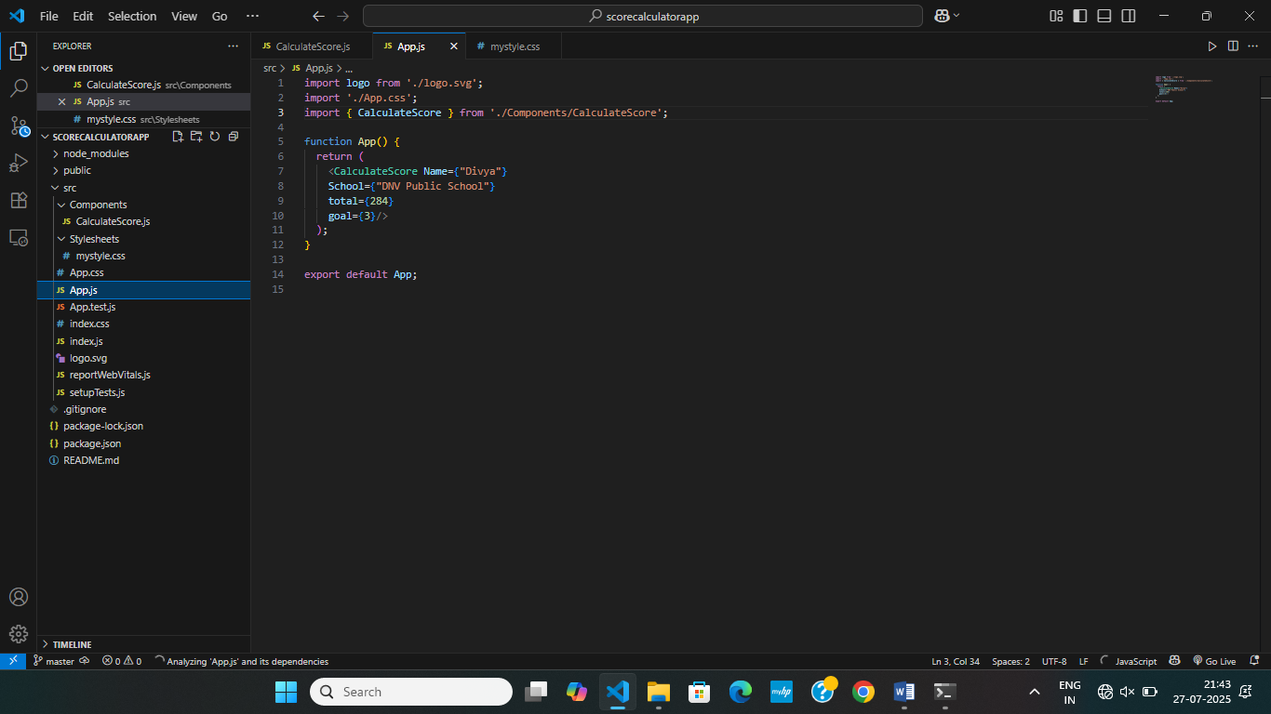

OUTPUT:

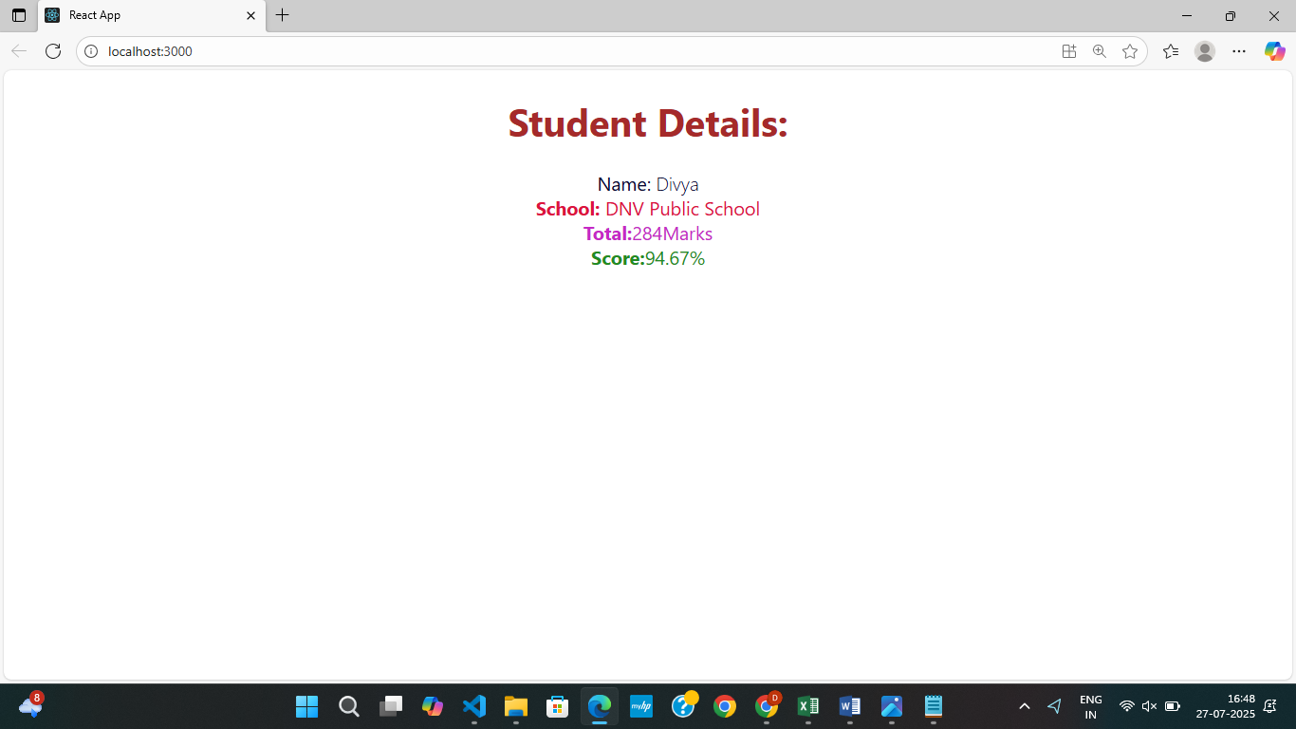

4**. ReactJS-HOL**

**STEP 1:** To create a new React app, Install Nodejs and Npm from the following link:

<https://nodejs.org/en/download/>

**STEP 2:** Install Create-react-app by running the following command in the command prompt:



**STEP 3:** To create a React Application with the name of “studentapp”, type the following command:

C:>npx create-react-app blogapp

**STEP 4:** Once the App is created, navigate into the folder of studentapp by typing the following command:

C:>cd blogapp

Post.js:

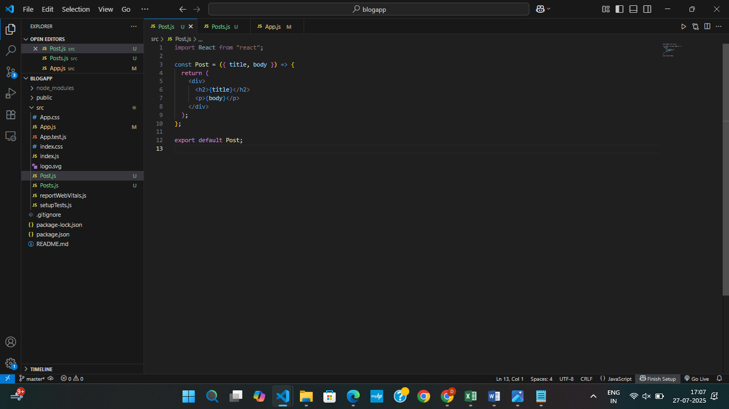

Posts.js:

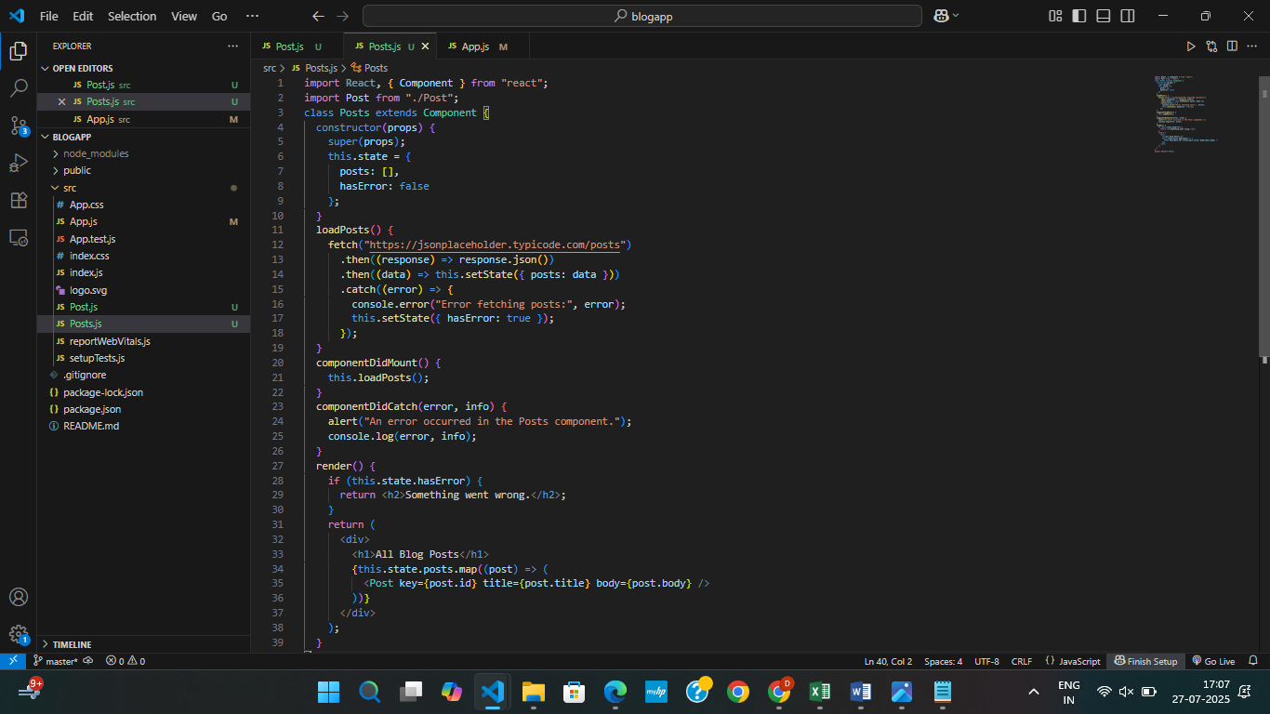

**App.js**

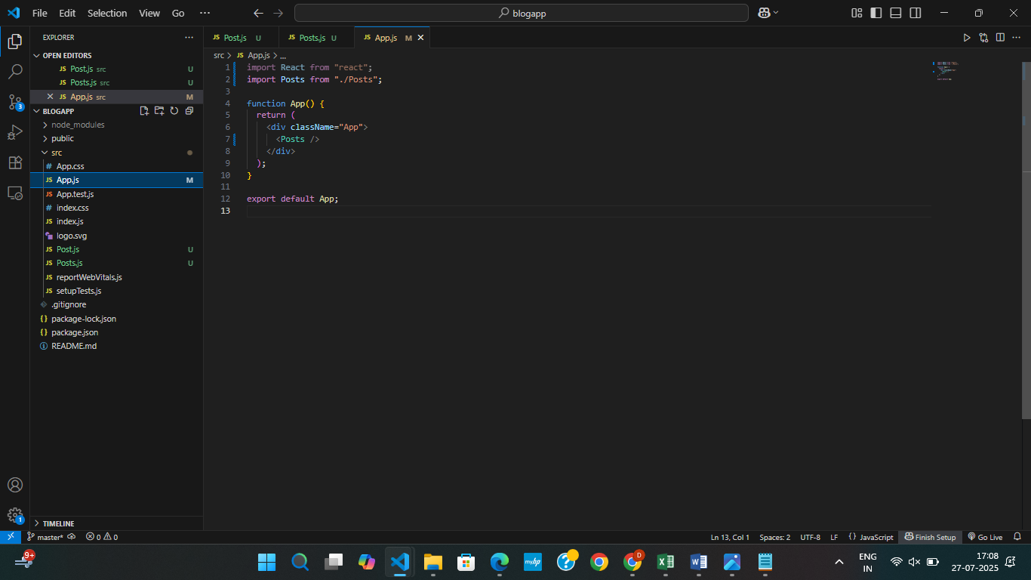

**OUTPUT:**

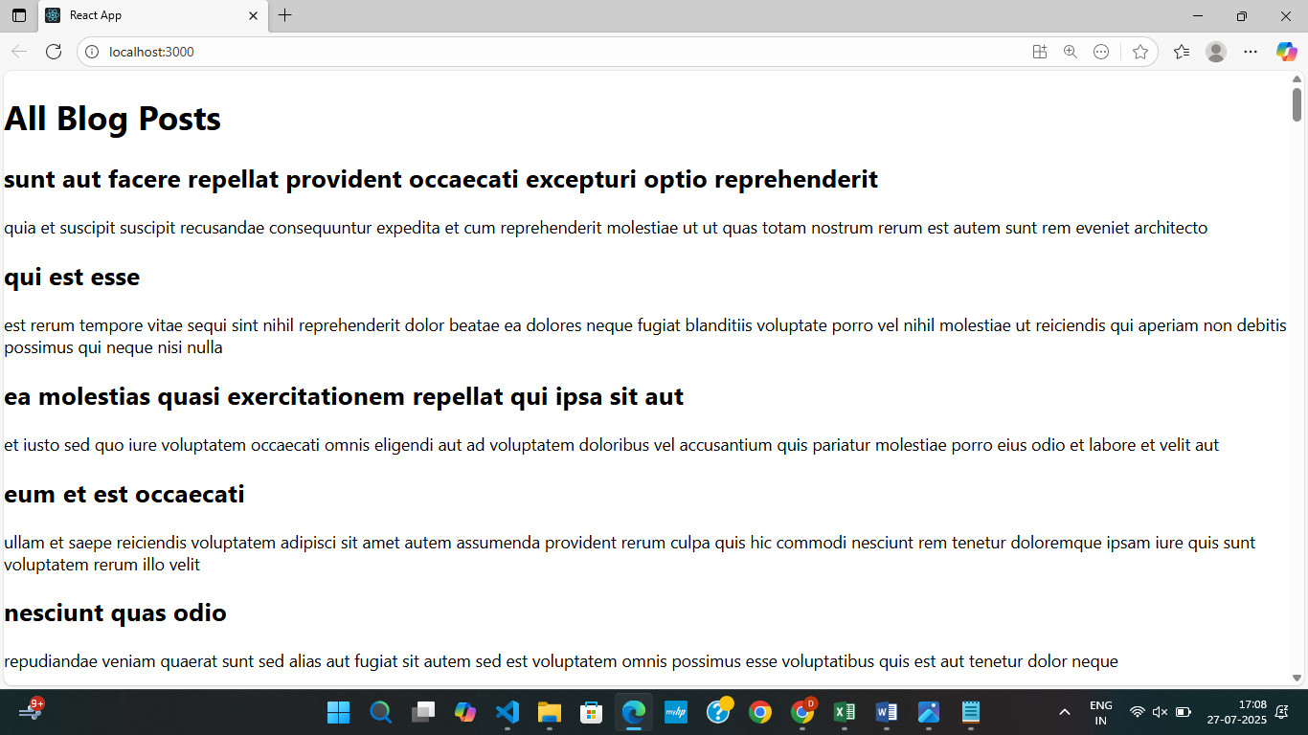

**5. ReactJS-HOL**

**STEP 1:**  Unzip the react application in a folder

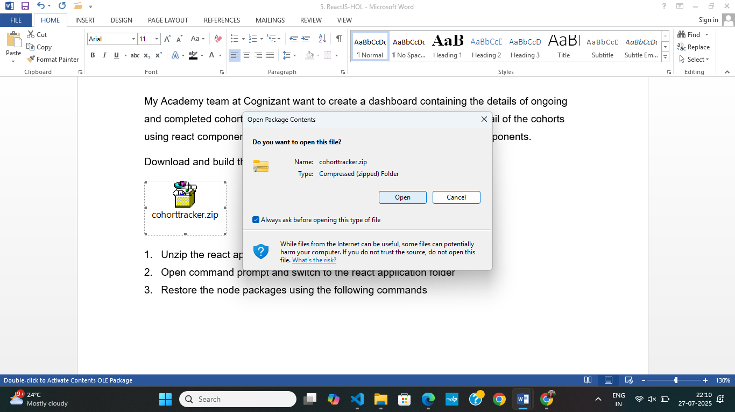

**STEP 2:** Open the folder in vs code

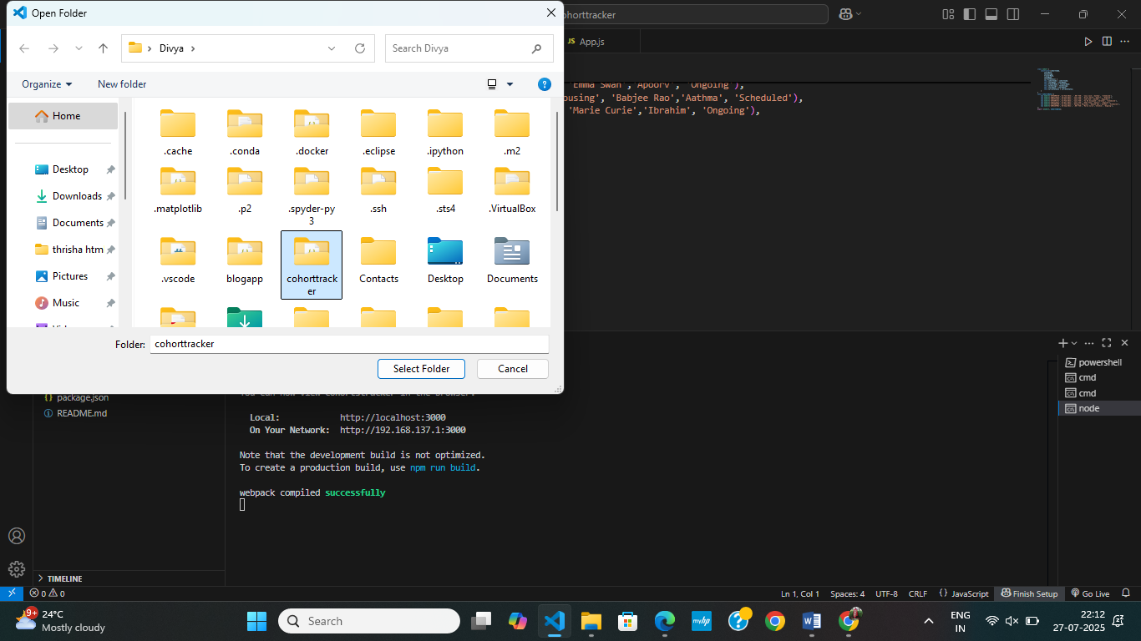

**STEP 3**: Add cohortdetails.modules.css

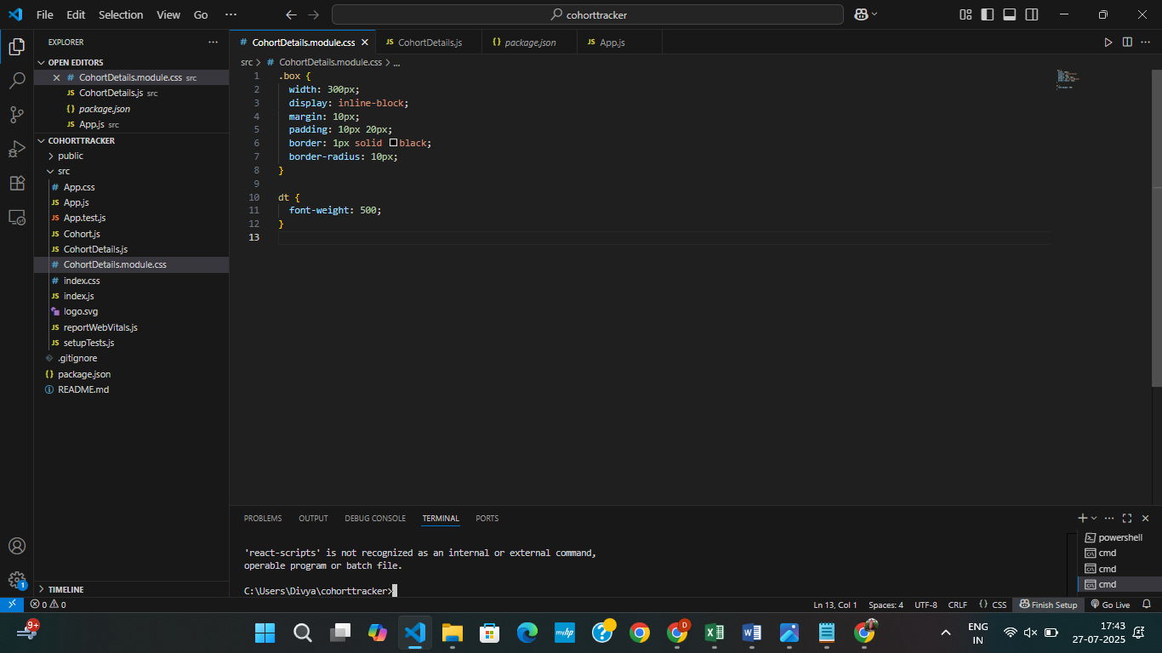

**STEP 4:** Update the CohortDetails.js by adding import statement

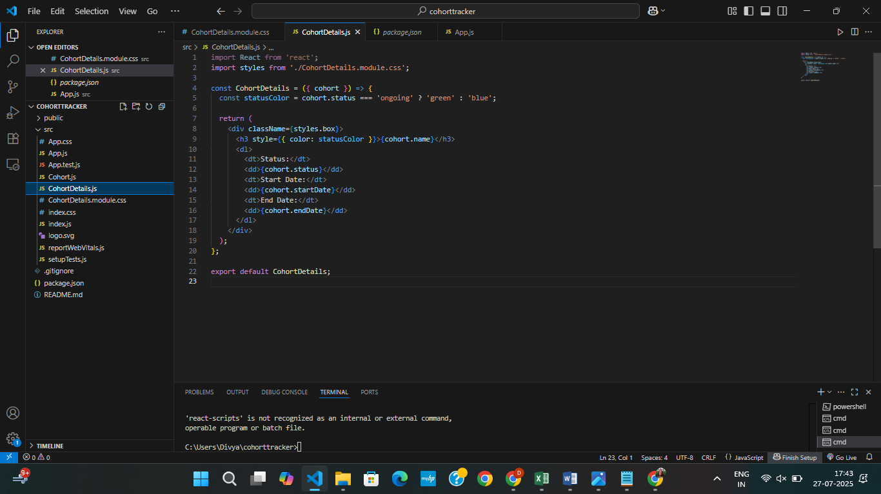

**App.js**

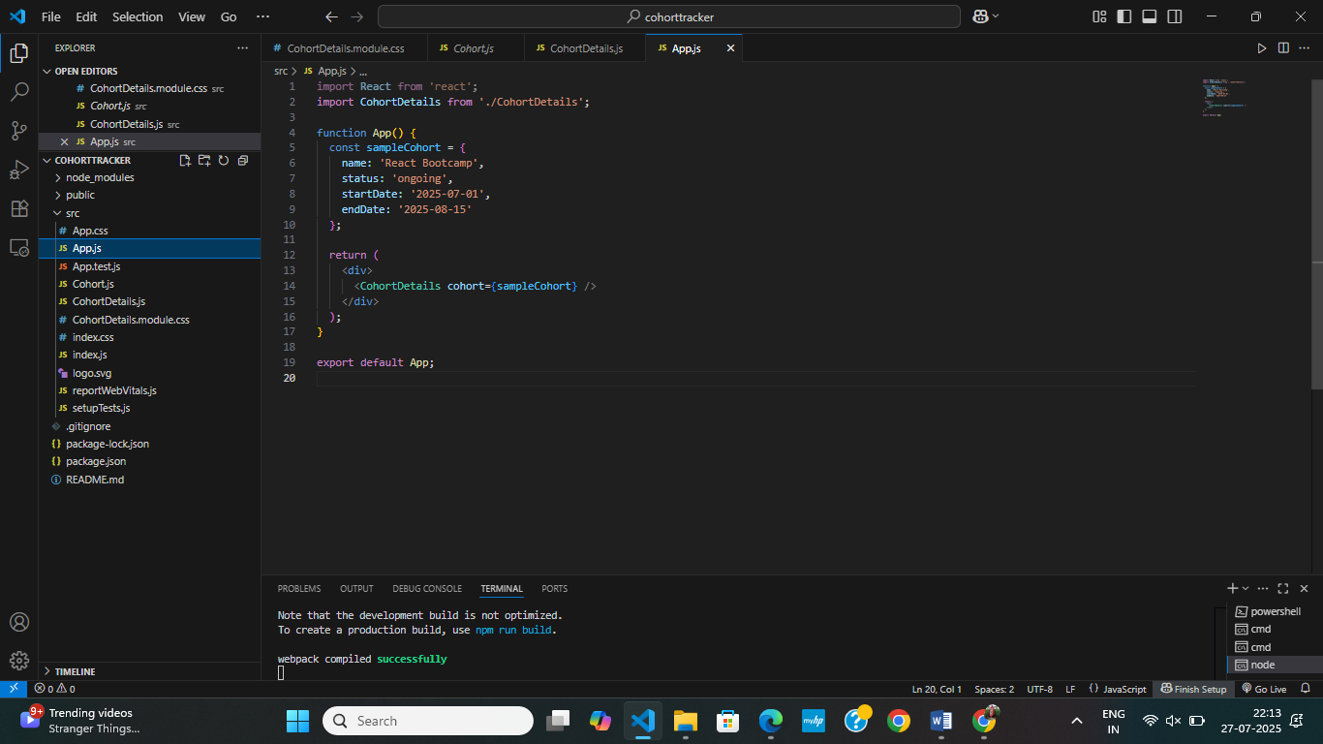

STEP 5: To run

C:>npm start

**OUTPUT:**

